

**Prince Sultan University**

**Department of Computer & Information Science IS361: IS Project Management**

**Smart Home Automation System**

**Group Members:**

**Rawan Alugayel 220511462**

**Norah Alrubayan 220410543**

**Dana Alghamdi 220410898**

**Najd Almedlej 220511414**

**Salma Alhamed 221410638**

**Instructor: Dr. Rabia Latif**

Table of Contents

Project Charter 4

Project Title 4

Project Start Date 4

Project Finish Date 4

Budget information 4

Project Manager 4

Description 4

Purpose: 4

Success Criteria: 4

Project Team 5

Functionalities 5

Scope Statement 7

System / Project Features: 7

WBS 8

Critical Path Analysis 8

Cost Estimations 9

SWOT Analysis 10

Strengths: 10

Weaknesses: 11

Opportunities: 11

Threats: 11

Performance Reports 12

Gantt Chart 13

Network Diagram 13

Initiation Phase 13

Planning Phase 14

Execution Phase 14

Closing Phase 15

Human Resource Report 15

Customized Report 1 15

Customized Report 2 16

Project Execution: 16

Progress Report: 17

Milestone Report 17

Screenshots 18

1. Homepage 18

2. Features Page 18

3. Team Page 19

4. Report Page 19

# Project Charter

|  |  |
| --- | --- |
| Project Title | Smart Home Automation System |
| Project Start Date | 14 July 2024 |
| Project Finish Date | 14 Aug 2024 |
| Budget information | The Budget of the project is $300,000. Most of the cost of the project is dedicated for website development, software, and hardware updates. |
| Project Manager | Rawan Alugayel |

|  |
| --- |
| Description |
| The smart home automation system encompasses the integration of a variety of household devices, ranging from lights and thermostats to security cameras and appliances, all interconnected through a centralized control hub or software application. This network enables homeowners to remotely monitor and manage their home environment from anywhere with internet access. Devices communicate via technologies like Wi-Fi, Zigbee, or Z-Wave,  ensuring seamless interoperability. Automation plays a key role, allowing for the creation of customized rules and schedules that automate tasks such as adjusting lighting based on occupancy or optimizing heating and cooling settings based on external conditions. The system aims to streamline daily routines, enhance comfort, and facilitate proactive management of energy consumption. |
| Purpose: |
| The primary goal of implementing a smart home automation system is to transform traditional residential spaces into intelligent, responsive environments that significantly enhance the overall quality of life for occupants. By leveraging automation and remote access capabilities, the system seeks to maximize convenience by simplifying routine tasks and providing intuitive controls accessible via smartphones or other devices. Moreover, the integration of security features such as smart locks and surveillance cameras enhances home safety, offering peace of mind through real-time monitoring and alerts. Energy efficiency is another critical objective,  achieved through optimized usage of devices and systems that can adapt to changing  conditions and user preferences. Ultimately, the smart home automation system aims to  empower homeowners with greater control, efficiency, and security within their living spaces. |
| Success Criteria: |
| 1. Functionality and Reliability: Ensure all devices integrate seamlessly and automation functions correctly. 2. User Experience: Provide an intuitive interface and reliable operation for users. 3. Security and Privacy: Implement strong measures to protect data and ensure device security. 4. Energy Efficiency: Optimize energy usage through smrt management of devices. 5. Support and Maintenance: Offer responsive support and regular updates to maintain system performance. 6. Cost-effectiveness: Demonstrate a positive return on investment and scalability for future needs. |

## Project Team

|  |  |  |
| --- | --- | --- |
| Name | Contact | Position |
| Rawan Alugayel | [220511462@psu.edu.sa](mailto:220511462@psu.edu.sa) | Project Manager |
| Najd Almedlej | [220511414@psu.edu.sa](mailto:220511414@psu.edu.sa) | Design Manager |
| Salma Alhamed | [221410638@psu.edu.sa](mailto:221410638@psu.edu.sa) | Business Analyst |
| Norah Alrubayan | [220410543@psu.edu.sa](mailto:220410543@psu.edu.sa) | Development Manager |
| Dana Alghamdi | [220410898@psu.edu.sa](mailto:220511414@psu.edu.sa) | Front End Manager |

# Functionalities

1. **User Registration and Login:** Allow users to create accounts with personalized profiles. Implement secure authentication methods to protect user data, ensure privacy, and maintain the integrity of the system**.**
2. **Device Integration and Management:** Enable users to add, configure, and manage various smart devices, such as lights, thermostats, security cameras, and smart locks, through a centralized platform. Ensure compatibility with a wide range of smart home devices.
3. **Remote Control and Monitoring:** Provide users with the ability to control and monitor their smart home devices remotely via a mobile app or web interface. Include real-time status updates and alerts for device activities.
4. **Automation and Scheduling:** Allow users to set up automation rules and schedules for their smart devices. For example, users can program lights to turn on at sunset or the thermostat to adjust based on their daily routine.
5. **Voice Control Integration:** Integrate with popular voice assistants (e.g., Amazon Alexa, Google Assistant) to enable voice control of smart home devices, enhancing convenience and accessibility.
6. **Security and Surveillance:** Offer advanced security features such as motion detection, video recording, and real-time alerts. Allow users to view live feeds and recorded footage from security cameras and receive notifications of suspicious activities.
7. **Energy Management:** Provide tools to monitor and manage energy consumption of smart devices. Offer insights and recommendations to optimize energy usage,

contributing to cost savings and environmental sustainability.

1. **User Notifications:** Automatically send notifications to users regarding device status, alerts, updates, and maintenance reminders. Notifications can include security alerts, energy usage reports, and scheduled automation triggers.
2. **User Reviews and Feedback:** Allow users to rate and review the performance of their smart devices and the overall system. Enable administrators to monitor user feedback and address issues to improve service quality.
3. **Reporting and Analytics:** Generate comprehensive reports and analytics on device usage, energy consumption, security incidents, and user interactions. Use these insights to inform strategic decision-making and system improvements.
4. **Admin Panel:** Provide administrators with a centralized dashboard to manage users, devices, automation rules, and system settings. Include tools for troubleshooting, user support, and system maintenance.
5. **Multilingual Support:** Offer support for multiple languages to cater to a diverse user base, enhance accessibility, and promote inclusivity.
6. **Interoperability with Other Systems:** Ensure the smart home system can integrate with other home automation ecosystems and third-party servicespp (e.g., IFTTT, SmartThings) for expanded functionality and flexibility.
7. **Data Privacy and Security:** Implement robust data protection measures, including encryption, secure storage, and regular security audits, to safeguard user data and maintain trust.
8. **Customization and Personalization:** Allow users to customize their system interface, automation rules, and notification preferences to suit their individual needs and preferences

# Scope Statement

The aim of the project is to design and implement a smart home automation system that enhances the convenience, security, and energy efficiency of residential properties. The system will integrate various smart devices and sensors to enable remote monitoring and control of home

appliances, lighting, security systems, and environmental controls.

# System / Project Features:

* User Registration and Authentication
* Multi-User Access Control
* Device Compatibility and Integration
* Centralized Control Hub for Devices
* Automated Device Discovery
* Customizable Automation Rules
* Voice Control Integration (Alexa, Google Assistant, Siri)
* Remote Access via Mobile/Web Apps
* Real-Time Monitoring and Live Feed
* Alerts and Notifications for Security and Device Status
* Detailed Access Logs
* Intuitive Dashboard Interface
* Mobile Application for iOS and Android
* Responsive Design for Various Devices
* Firmware Updates and System Maintenance
* Diagnostics and Troubleshooting Tools
* System Testing and Quality Assurance
* User Testing and Feedback Integration
* Scalable System Architecture
* Secure Data Handling with Encryption
* User Training and Manuals
* 24/7 Customer Support Channels

# WBS

# Critical Path Analysis

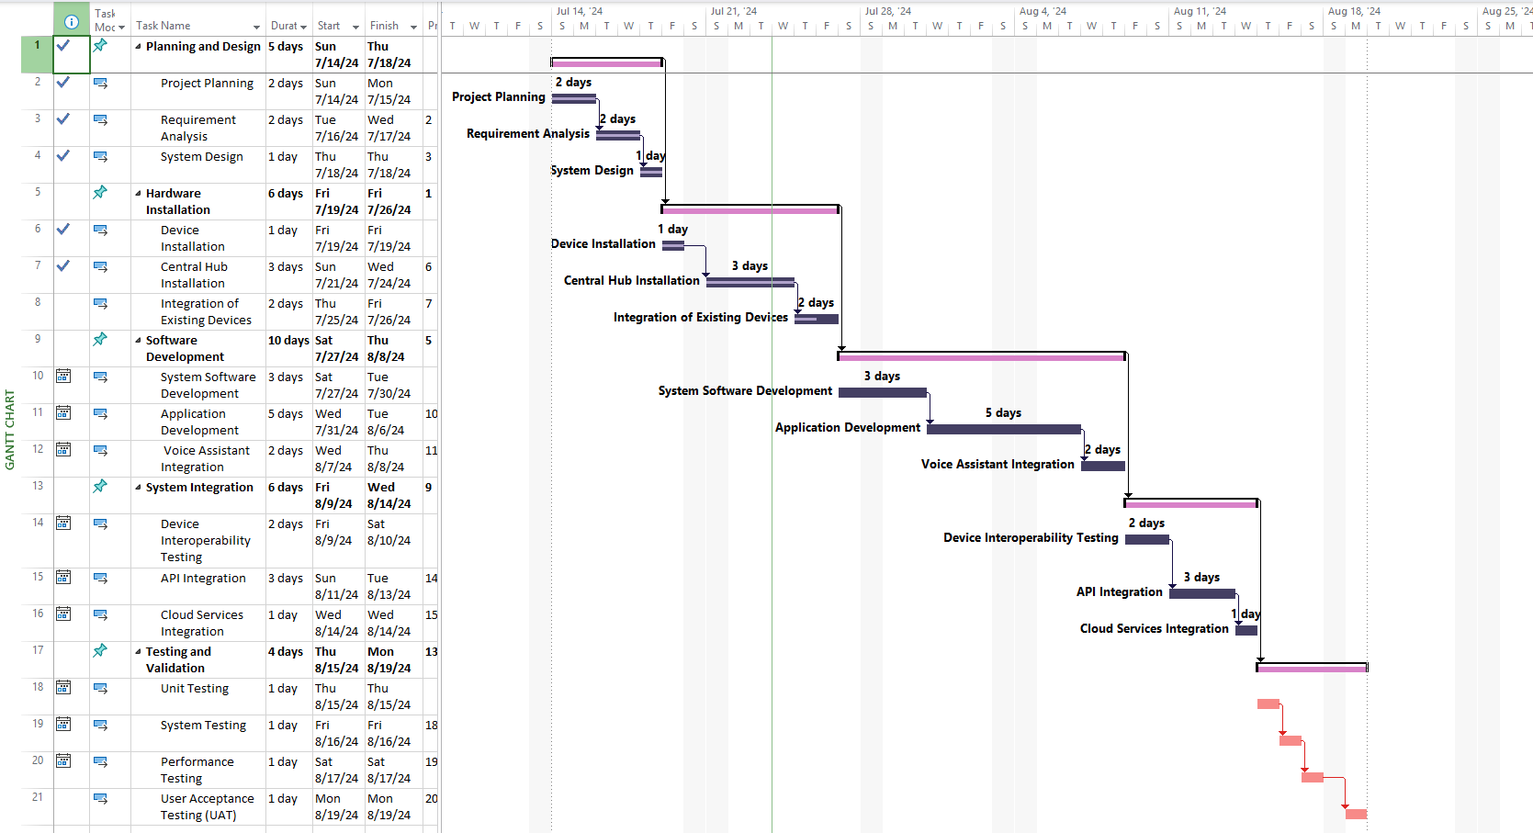

# Cost Estimations

Following is the allocation of the budget and estimated cost of each stage of the Smart Home Automation System project. Each stage is explained with Associated Resources, Basic Calculation, and Total cost.

|  |  |  |  |
| --- | --- | --- | --- |
| **Stages** | **Associated Resources** | **Basic Calculation** | **Total** |
| Initializing | Project Manager and Business Analyst | 12% of the total Project Cost Estimate | 300,000 x 12% = $36,000 |
| Planning | Team of Project Managers | 13% of the total Project Cost Estimate | 300,000 x 13% = $39,000 |
| Executing | Developers | 40% of the total Project Cost Estimate | 300,000 x 40% = $120,000 |
| Controlling | System Security Employees, Consultants | 20% of the total Project Cost Estimate | 300,000 x 20% = $60,000 |
| Closing | Project Manager and Team | 10% of the total Project Cost Estimate | 300,000 x 10% = $30,000 |
| **Total** | | | **$300,000** |

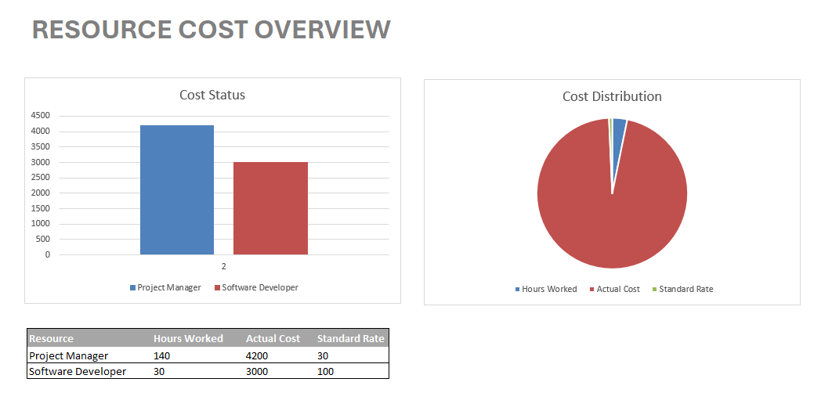

# SWOT Analysis

## Strengths:

1. **Convenience and Accessibility**:

The Smart Home Automation System provides homeowners with the ability to manage and monitor their home environment from anywhere with internet access, enhancing convenience and accessibility.

1. **Enhanced Security**:

Integration of security features such as smart locks and surveillance cameras offers real-time monitoring and alerts, significantly enhancing home safety.

1. **Energy Efficiency**:

The system optimizes energy usage by automating tasks like adjusting lighting and temperature based on occupancy and external conditions, leading to reduced energy consumption and cost savings.

1. **Customizability and Automation**:

Users can create customized rules and schedules, allowing for tailored automation of daily tasks, improving comfort and efficiency.

1. **Scalability**:

The system is designed to accommodate an increasing number of clients and devices, making it scalable for future expansion.

## Weaknesses:

1. **Dependence on Internet Connectivity**:

The system's functionality relies heavily on stable internet connectivity, which can be a limitation in areas with poor internet service.

1. **Initial Investment Costs**:

Significant upfront investment is required for system development, including software, hardware, and infrastructure.

1. **Complexity and User Adaptation**:

The system might be complex for some users, leading to a steep learning curve and potential resistance from users accustomed to traditional home management methods.

1. **Third-Party API Dependence**:

Reliance on third-party APIs for integrating various smart devices and services can pose risks if those services change or become unavailable.

## Opportunities:

1. **Market Expansion**:

There is potential to enter new markets, including rural areas and international regions where smart home automation is still emerging.

1. **Collaborations and Partnerships**:

Opportunities for collaboration with tourism industries, hotels, and transportation sectors can lead to broader applications and adoption of the system.

1. **Technological Advancements**:

Continuous improvement and innovation in smart home technologies provide opportunities to enhance system features and stay ahead of competitors.

1. **Data-Driven Insights**:

Utilizing data from the system to gain insights into user behavior and preferences can help in improving services and creating personalized experiences.

## Threats:

1. **Competition**:

The market for smart home automation is highly competitive, with numerous existing and emerging players offering similar solutions.

1. **Regulatory Compliance**:

Adherence to local and international regulations related to data protection and privacy can pose challenges and require ongoing adjustments to the system.

1. **Economic Fluctuations**:

Changes in economic conditions, such as fluctuations in fuel prices, exchange rates, and overall economic instability, can impact consumer spending and adoption rates.

1. **Technological Risks**:

Rapid advancements in technology could lead to the system becoming outdated quickly, necessitating continuous updates and improvements to stay relevant.

# Performance Reports

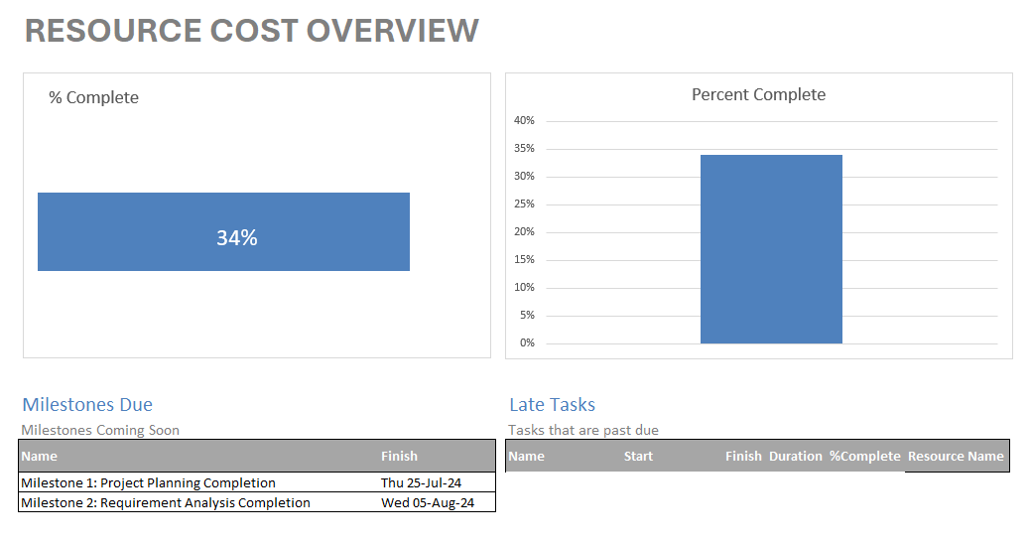

# Gantt Chart

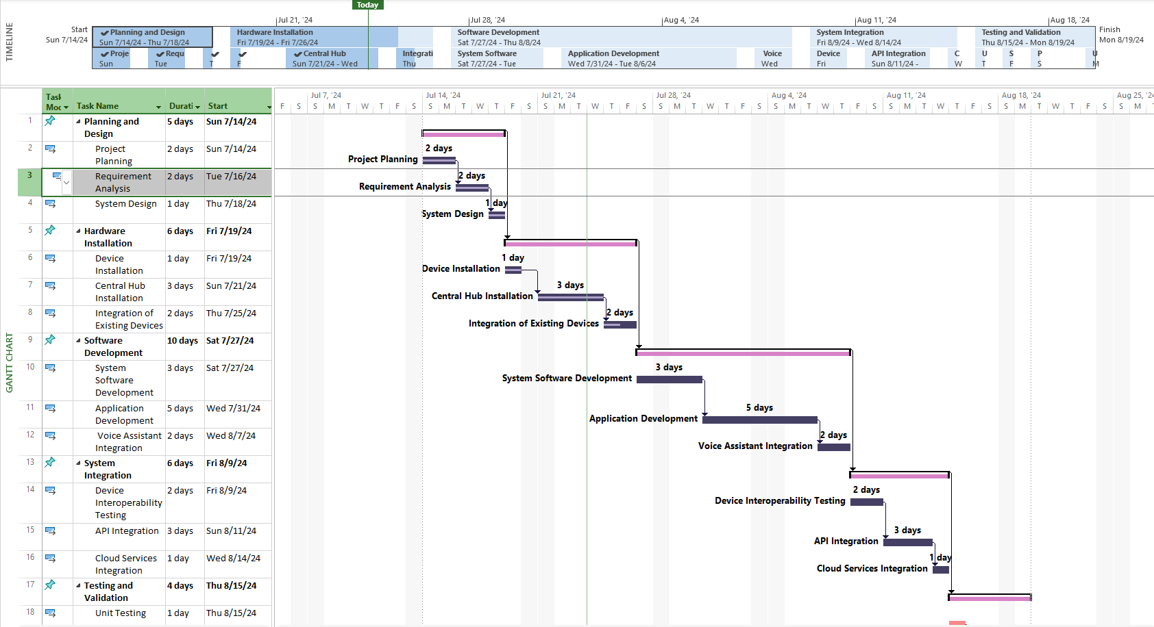

# Network Diagram

## Initiation Phase

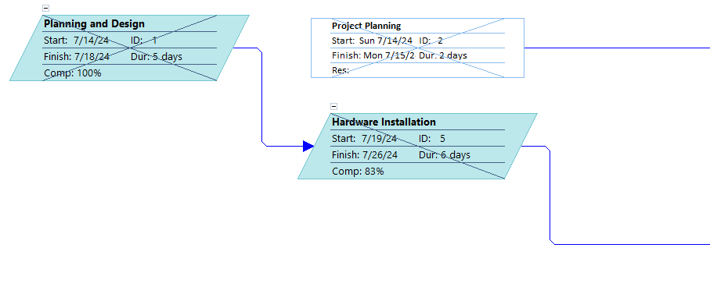

## Planning Phase

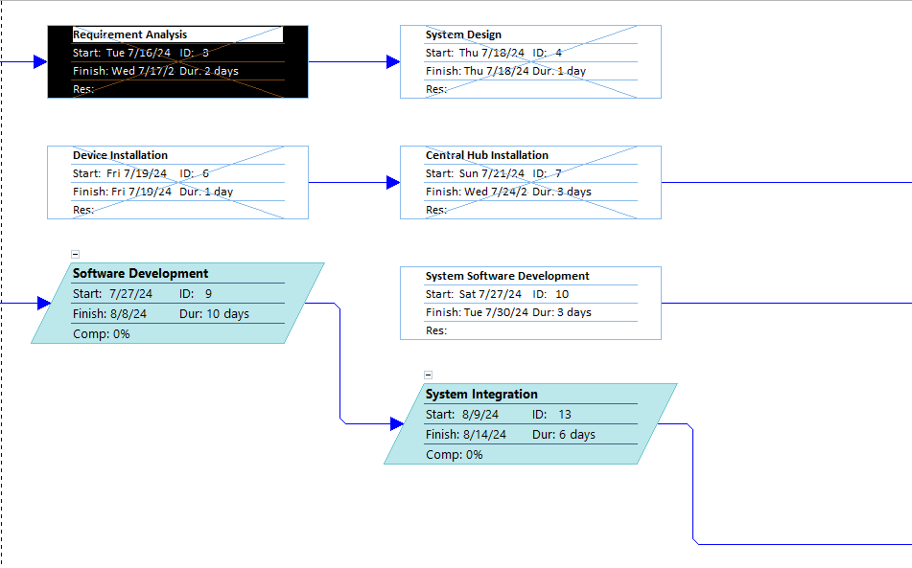

## Execution Phase

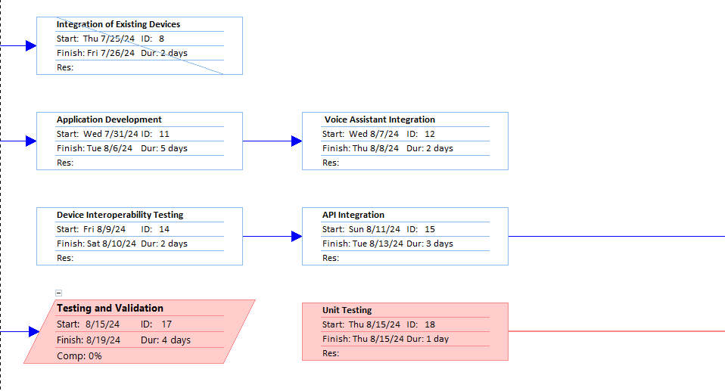

## Closing Phase

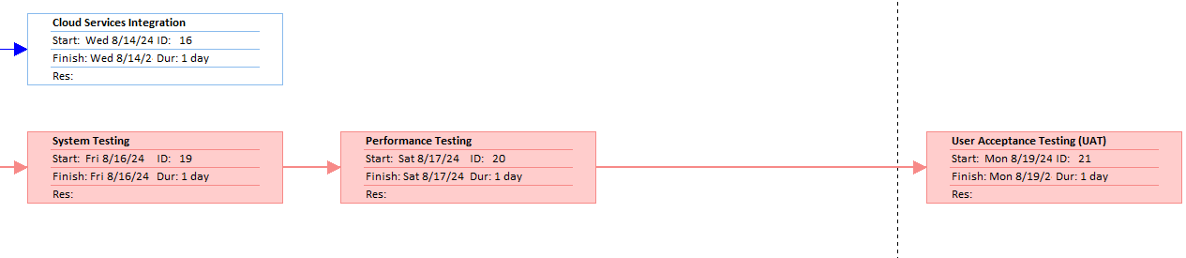

## Human Resource Report

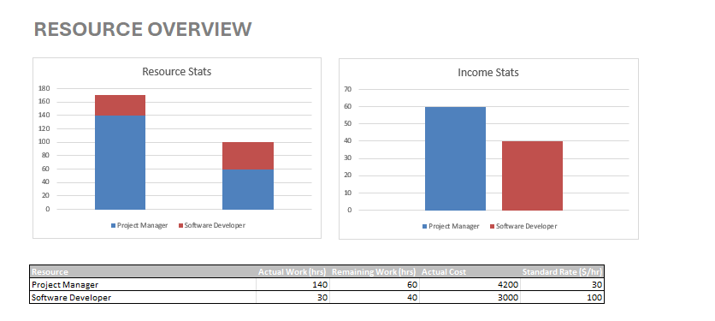

## Customized Report 1

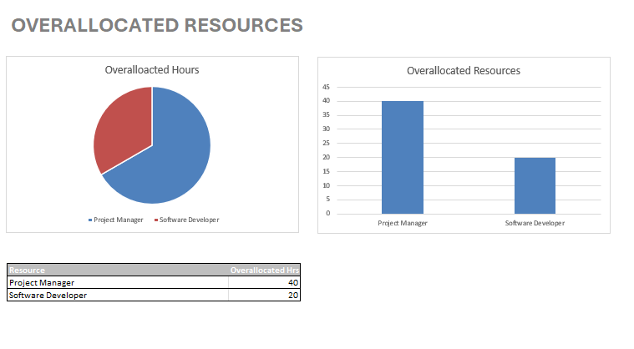

## Customized Report 2

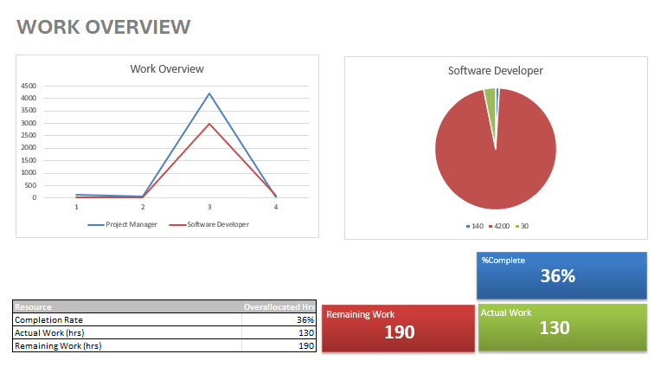

## Project Execution:

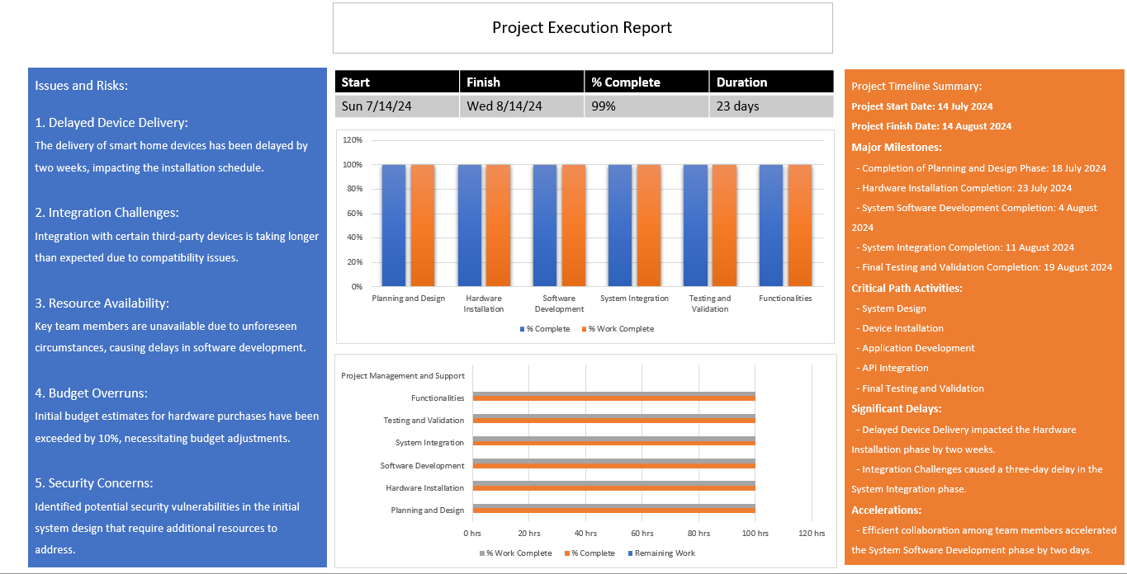

## Progress Report:

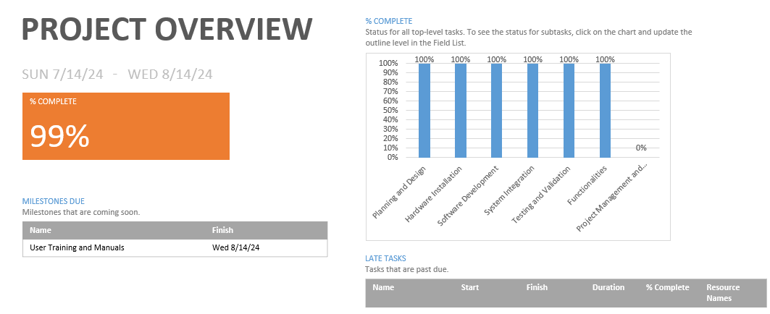

## Milestone Report

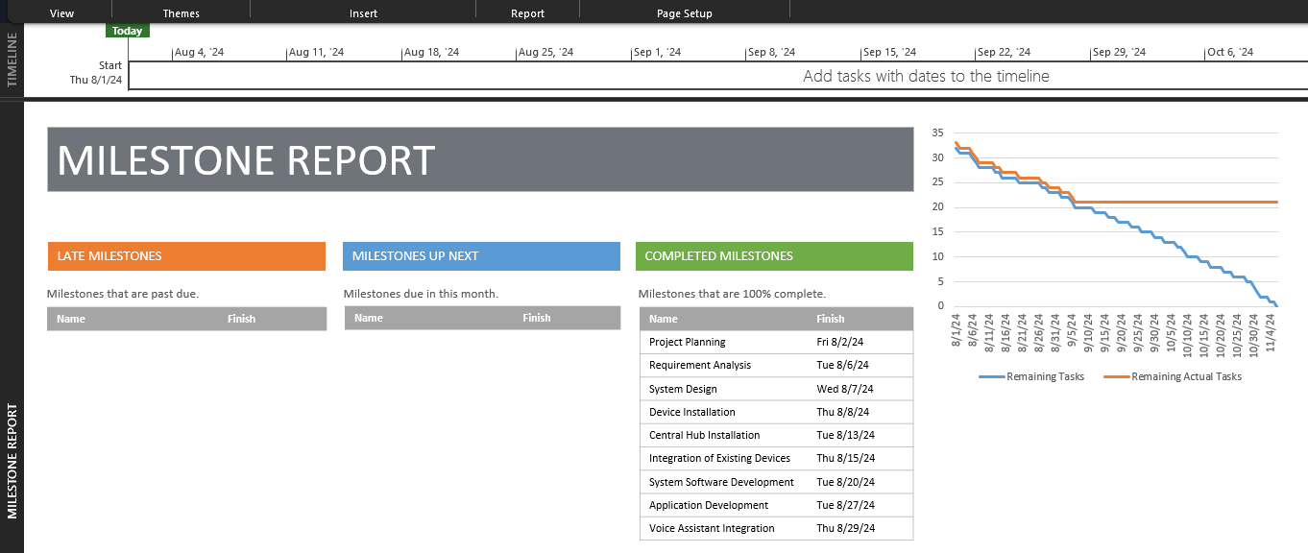

# Screenshots

## 1. Homepage

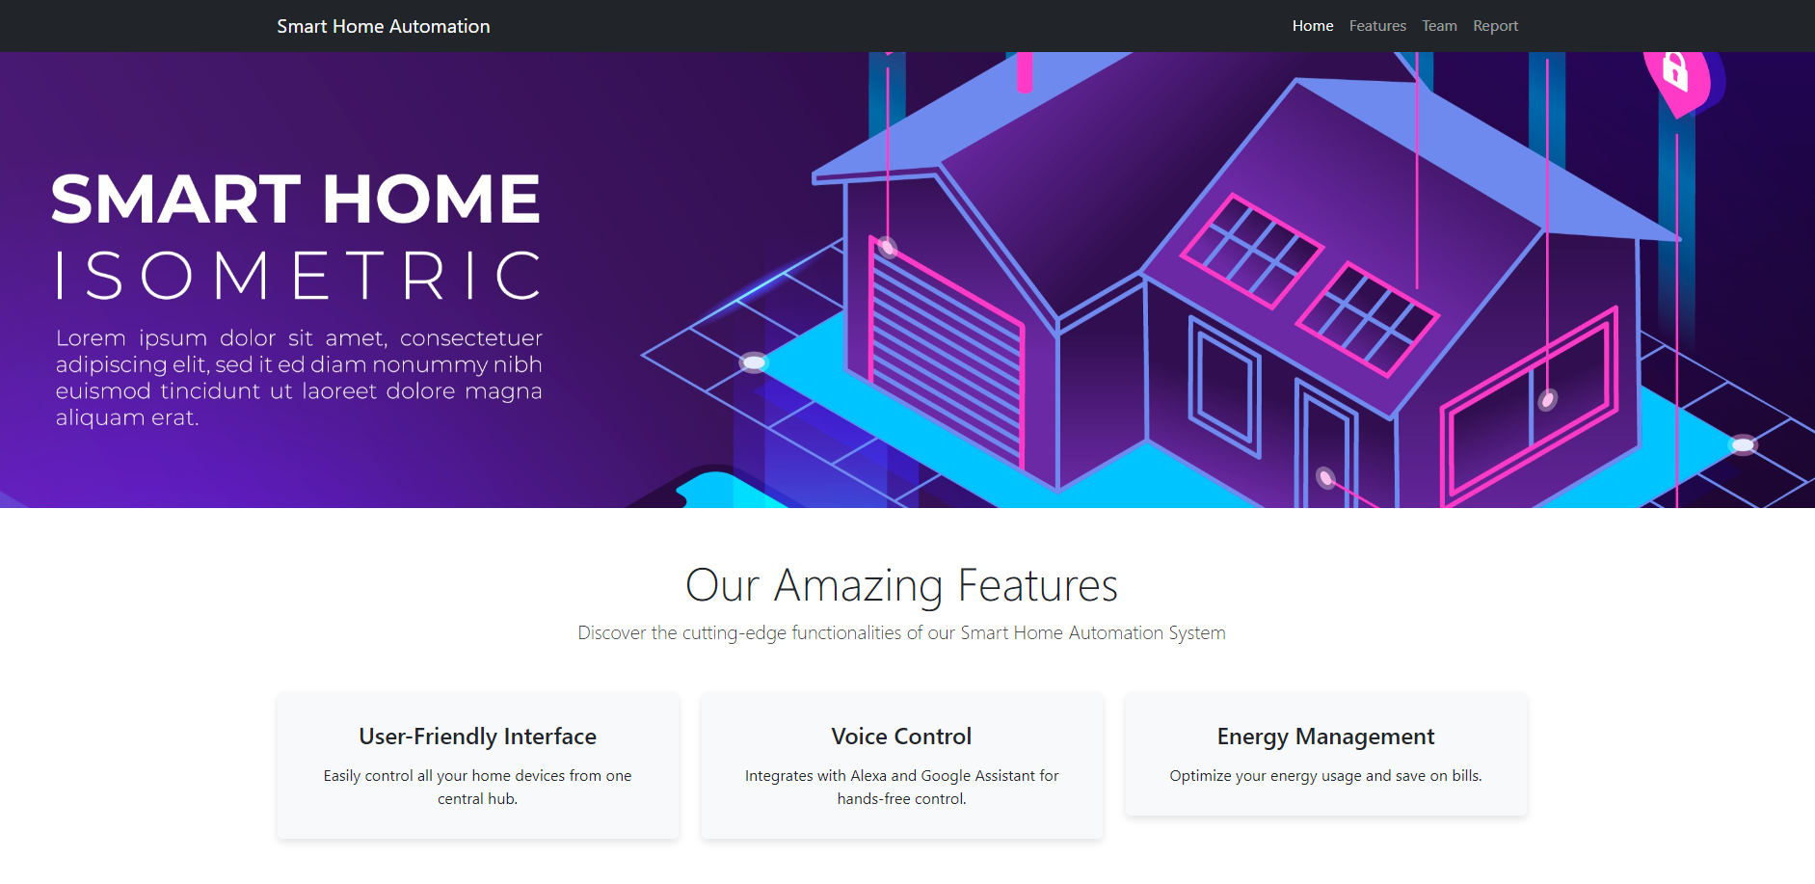

The homepage provides an overview of the Smart Home Automation System, highlighting its key features and inviting users to explore more.

## 2. Features Page

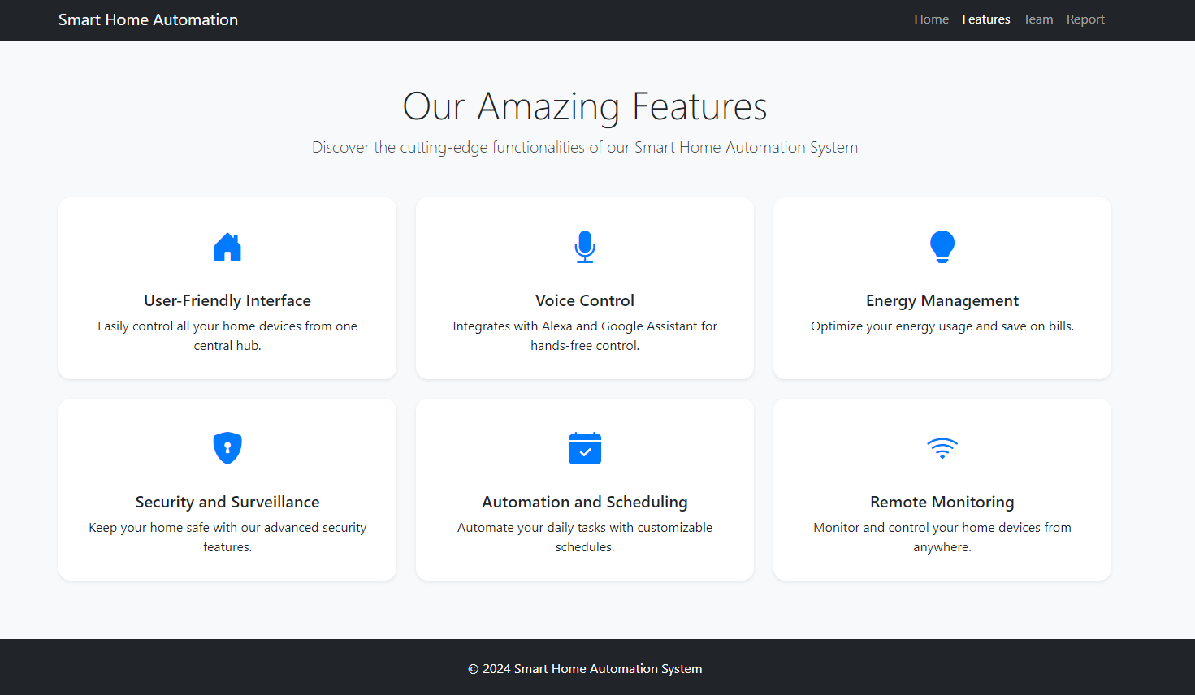

The features page details the various functionalities of the system, including user-friendly interface, voice control, and energy management.

## 3. Team Page

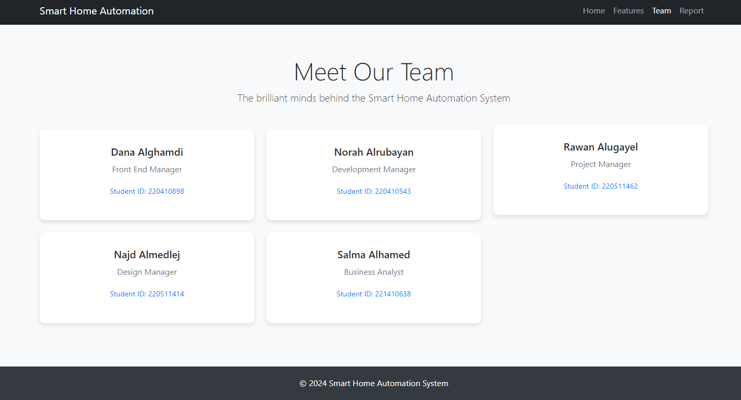

The team page introduces the project team, showcasing their roles and student IDs, emphasizing the collaborative effort behind the project.

## 4. Report Page

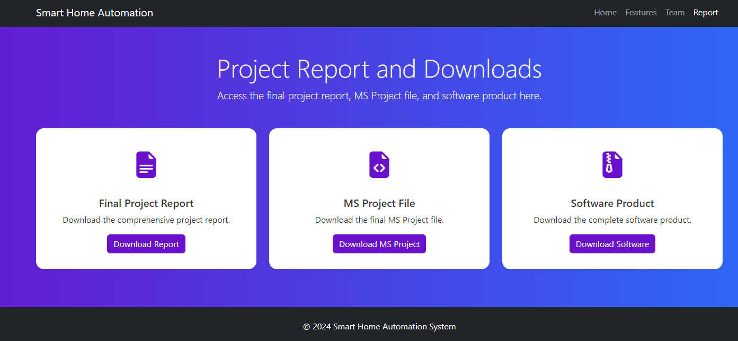

The report page provides access to the final project report, MS Project file, and the software product, allowing users to download these resources easily.

This detailed report outlines the comprehensive details of the Smart Home Automation System project, including its purpose, functionalities, and the brilliant team behind it. The screenshots provide a visual representation of the project's key components and user interface.